Asphalt Distributor Preventive Maintenance and Safety Checklist

The asphalt distributor (aka as the Asphalt Maintenance Unit or AMU) is the most complex piece of equipment used in seal coat construction work due to its many components. Each major part of an AMU must be properly maintained to function properly. An AMU may come in the form of a truck with a mounted insulated tank or as a pull-behind unit. Taken from the Texas Department of Transportation’s Seal Coat and Surface Treatment Manual, Chapter 7 Equipment Inspection, Section 3 – Asphalt Distributors, the following guidance is provided to help maintain your distributor.
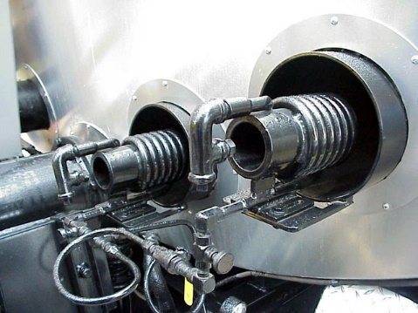
Image courtesy TxDOT Seal Coat Manual

Significant Components of AMUs to Inspect and Maintain

Heating System
Asphalt temperature is a critical factor in the success of a seal coat/surface treatment. To maintain a constant temperature, a proper heating system is necessary. Depending on the make and size of the AMU, either one or two propane or diesel-fired burners are used. The burners are mounted on the platform at the rear of the tank and are positioned so the flame is directed into the flues that pass through the tank. Burners and their ignitors need to be serviced to ensure that proper temperatures can be achieved for the type of asphalt, emulsion, or oil being applied. Temperatures as high as 375° are used for some types of asphalt cement.

Circulation and Pumping System
All AMUs must have a power-driven pump to spray asphalt under pressure onto the roadway. The pumps also serve to provide a circulation system. Two systems are commonly used to supply pressure to the spray circulation system. One system has a separate engine mounted at the rear of the tank. This engine provides power to the pump only. The other system uses power from the truck engine to operate the pump. This is called a hydrostatic distributor system. The pump should be inspected to ensure that it provides power to perform the following functions:
- Circulate the asphalt throughout the tank. This is necessary to prevent asphalt from burning if it remains next to the flues for an extended period. Also, it will prevent asphalt from staying near the tank’s skin long enough to cool and harden.
- Circulate asphalt through the spray bar and bring unused asphalt back into the tank. This will prevent asphalt from remaining in the spray bar long enough to cool, harden, and clog the spray nozzles.
- Pump unused asphalt out of the distributor.
- Pump from one storage tank to another. It may be used as an auxiliary pump to transfer asphalt from one tank to another.
- Fill the distributor tank. If a storage tank, heater unit, or transporter unit is not equipped with a pump, the distributor spray pump may be used to fill the distributor tank.
- Pumps should be inspected to ensure they are not leaking from seals.

Filter Screens
Most distributors have filter screens in the main piping between the tank and the spray bar. The purpose of these wire-mesh filters is to prevent particles of burned asphalt or impurities from entering the spray bar and clogging the spray nozzles. Screens should be removed and washed with diesel fuel, or particles should be burned off with a torch. This will prevent a blockage of the flow of asphalt, allowing it to flow under full pressure to the nozzles. On a large project, the filters should be cleaned periodically.

Spray Bar and Nozzles
The spray bar and spray nozzles regulate the amount of asphalt sprayed on the roadway and regulate the spray pattern. The spray bar on most AMUs used on seal coat projects is 12 feet wide – the width of a typical traffic lane. Different bar widths are available. The bar comprises a series of spray nozzles evenly spaced (every 4 inches) along the bar. Nozzles are manufactured with various size openings to permit different application rates of asphalt. Nozzles are designed to spray a fan-shaped pattern rather than a circular spray. Taken from TxDOT’s Seal Coat Manual, the figures below show proper nozzle alignment. From the top, proper nozzle alignment is shown in the figure to the left. Viewed from the rear of the AMU, the spray pattern is shown in the figure to the right. Always check nozzle alignment before and during applications for proper patterns.
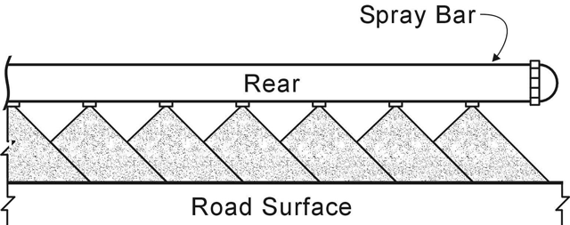
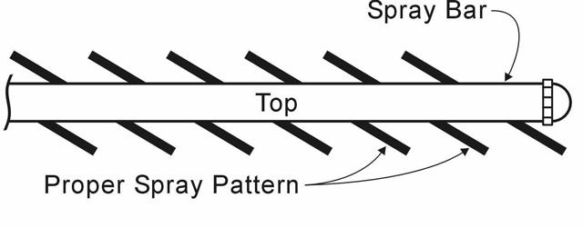

The bar contains a return line for continuous circulation of asphalt through the bar. Most spray bars are hinged at each end to allow the end to be folded up when spraying is not in progress. The AMU should never be driven in traffic with the ends extended because they extend beyond the truck’s sides. Some have chains attached at the ends of the bar and to the truck chassis. The chains help to support the ends of the bar when they are in the spray position. Chains may also serve as a safety hitch to hold the ends securely in the upright position.

Hand Sprayer
Distributors typically are equipped with a hand sprayer for use in narrow, irregular-shaped areas that are inaccessible to the spray bar. The handle on the sprayer also serves as the shut-off valve control. To turn the spray on, the operator turns the handle 90°. Inspect the handle for easy movement and that the supply line to the sprayer is not leaking and has adequate thermal protection so the operator will not get burned if they touch the supply line.

Controls and Gauges
Thermometer. As mentioned earlier, a thermometer is used for monitoring asphalt temperature. Most are in a well on the side of the tank. Some models have a dial thermometer mounted on the outside of the tank, with a thermocouple inside the tank.

Volume Gauge. Most tanks are equipped with a volume gauge. These should be used only as a convenience to the operator to know when the tank is getting close to empty.


Strap Stick. The manufacturer supplies a measuring stick (strap stick) with the distributor. Some distributors have the gallon levels on the stick itself. Others have a metal scale riveted on the side of the frame.

Other Resources Available from TxLTAP

The TxLTAP Program has an excellent video on the proper use and maintenance of an AMU on YouTube. The video is 5 minutes long and is an excellent refresher on operations and safety tips. Use the link at: https://www.youtube.com/watch?v=cvp7E_u2iws

