# **Equipment Load and Tiedown Safety and Techniques**

When it comes to securing heavy equipment, one important concept to know is understanding the working load limit (WLL). According to the Federal Motor Carrier Safety Administration (FMCSA), WLL is defined as “the maximum load that may be applied to a component of cargo securement system.” All tie-down components like chains and straps will have a WLL rating. The tie-downs combined must be rated to support at minimum ½ times the weight of the cargo.

**The state of Texas has adopted all statutes published by the FMCSA. No private contractors or governmental agencies (yes – that includes all cities and counties in Texas) are not exempt from FMCSA load and tie-down requirements.**

Example: For a piece of equipment you are loading onto a flatbed trailer that weighs 30,000 pounds, you must secure one-half of the total weight, or at least 15,000 pounds. With four tie-downs on each corner, these must have a working load limit rated at a minimum of 3,750 pounds.

## ***Tips on Securing Loads Properly***

### ***Truck and Trailer Inspection***

* Select a haul truck of the right size and capacity to haul the equipment. For example, you would not use a Ford F250 (equipped with V8 6.7L Power Stroke Turbo diesel rated with a towing capacity of 22,800 lbs.) to haul a 30,000 load.
* Inspect truck and trailer, look for tire pressure on trailer tires (most overlooked item on a pre-operational checklist), brakes, lights, tie-down points. Inspect the deck on the trailer to make sure it has no rotten boards or holes and is free of mud or ice.
* Check for overhead clearance of the machine that it does not exceed the height of any bridges you will be passing under.

### ***Chains, Binders, and Hooks***

* Inspect chains and ratchet binders. If chains or binders have been involved in an accident (such as a load shifting, coming off a trailer, or load overturn), do not use them again. They have been stressed, and the WLL has been reduced.
* When possible, do not mix different grades of chains and binders.
* Inspect chains and binders to ensure they are Grade 70 or higher. Ensure the grade of the chain and WLL is equal to or greater than the binder on the chain.
* Chains and hooks are the same sizes, i.e., 3/8ths, 5/8ths, etc. Do not mix one hook with a different size chain; it will not hold properly or slip during transport.

### ***Image result for Equipment Tie Down PointsTie-Down Points***

* All heavy equipment will have factory tie-down points on the frame. There is no universal tie-down point emblems in use, each OEM is different.
* Use the factory tie down points for chain securement as shown in this picture.
* Note that excess chain is wrapped around the chain and binder.

Image courtesy of blogspot.com

### ***To Cross or Not to Cross?***

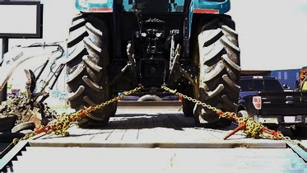

DO NOT CROSS CHAINS when securing a load. Chains should be left-left and right-right oriented for the main tie-downs. Chains may be used from left-right when securing items such as the bucket on a loader.

This example shows proper chain placement PULLING DOWN.

Image courtesy of uscargocontrol.com

### ***Load Securement***

* Chains should never be twisted as it will reduce the strength of the WLL of the chain/binder system.
* No weight-bearing portion of the load should be placed on the loading ramp of the trailer.
* Always load/unload on sold level ground away from traffic hazards. Check the condition of the area you are loading into to make sure the ground will not sink and mire the trailer and equipment when loaded.
* Any attachments to equipment (such as a backhoe) must be chained separately from the frame. A backhoe would require four chains on the main unit frame, plus a chain for the front bucket and another chain on the rear digging bucket for a total of 6 chains in use.
* Always make sure that chains are tight when you initially secure them. If transporting more than 5 miles, stop after 5 miles and recheck the load to ensure it has not shifted and chains are still tight.

### ***Trailer Load Balancing***

Adapted from the website Fleetistics ([Trailer Load Balancing Improves Safety | Fleetistics Fleet Management](https://www.fleetistics.com/trailer-load-balancing/)), trailer load balancing is essential because it is crucial to achieving a properly loaded trailer. We have all seen an overloaded trailer rolling down the highway at some point. Tree trucks, roofing materials, rock or tile, and heavy equipment all come to mind for unsafe trailer loading. Remember, balance will make a huge difference in vehicle safety and stability, and the result is a safer, more comfortable ride.

Improper load balancing can result in swaying your trailer, resulting in loss of equipment or an accident. It can also result in too much weight being placed to the front of the trailer on the hitch or the rear, causing “see-sawing” of the trailer. Balancing also includes side-to-side on the trailer. You do not want all of a 6’ wide piece of equipment loaded entirely to the left or right; it should be centered on the trailer as much as possible.

The proper tongue weight on a haul truck should be between 10 – 15% of the trailer weight. Don’t “guesstimate” load weight on a trailer. Trailers should be scaled to make sure you do not exceed the working load of the trailer. You should always know the weight of the load you are placing.

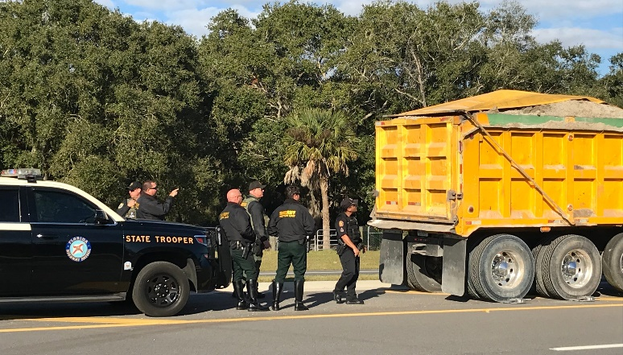

Always be safe and do not exceed allowable loads

in trucks or trailers you operate. We do not want to see a picture of your city or county truck pulled over

like we see here in Florida where the state troopers

have pulled over a municipal truck! The name of the

city shall remain anonymous to protect the guilty!

Image courtesy of Florida Highway Patrol