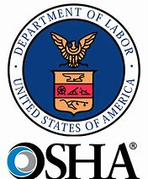**Personal Protective Equipment and You**

According to the United States Department of Labor, Occupational Safety

and Health Administration (OSHA): Personal protective equipment, commonly referred

to as "PPE", is equipment worn to minimize exposure to hazards that cause serious

workplace injuries and illnesses. These injuries and illnesses may result from contact

with chemical, radiological, physical, electrical, mechanical, or other work-place hazards.

PPE may include items such as gloves, safety glasses and shoes, earplugs or muffs, hard hats, respirators, or coveralls, vests, and full body suits.

## **What is your role in the proper use of personal protective equipment?**

Your PPE should be maintained in a clean and reliable fashion. It should fit comfortably. If the PPE does not fit properly, it can differentiate between being safely covered or dangerously exposed. The appropriate PPE should be selected and worn according to the type of work you are performing. At a minimum, reflective shirts/jackets and steel-toed boots should be daily attire.

## **Why use PPE?**

PPE is provided for you by your employer, not because of government regulation, not to make a fashion statement, not to make you and your crew all look alike – *they do it because they care about you.* PPE is to make sure you go home to your family at the end of the day as you came to work.

## **When to use PPE.**

When engineering, work practice, and administrative controls are not feasible or do not provide enough protection, employers typically provide personal protective equipment to their workers and ensure its proper use. You and your employer should know the following about PPE:

* When it is necessary (according to the job/task)
* What type(s) of PPE are necessary
* How to properly put it on, adjust, wear, take it off and store
* The limitations of the equipment
* The proper care, maintenance, useful life, and disposal of the equipment

## **Example of PPE use.**

The Texas Manual on Uniform Traffic Control Devices (TMUTCD), which all governmental agencies, cities, and counties in Texas must follow, has the following provision in Section 6D.03 ***Worker Safety Consideration*** that states: All workers, including emergency responders, within the right-of-way who are exposed either to traffic (vehicles using the highway for purposes of travel) or to work vehicles and construction equipment within the TTC zone shall wear high-visibility safety apparel that meets the Performance Class 2 or 3 requirements of the ANSI/ISEA 107–2004 publication entitled “American National Standard for High-Visibility Safety Apparel and Headwear” (see Section 1A.11), or equivalent revisions, and labeled as meeting the ANSI 107-2004 standard performance for Class 2 or 3 risk exposure, except as provided in Paragraph 5. A person designated by the employer to be responsible for worker safety shall make the selection of the appropriate class of garment.

**This provision means that if you are doing work on the city, county, or state roads or right-of-way, you must wear high visibility clothing.**

## **Types of PPE.**

There are numerous categories and types of PPE available on the market today. A precaution that should always be taken is to ensure that the PPE being considered for purchase and use meets all ANSI, ISEA, ASTM, and/or NFPA standards.

## **Hard hats**

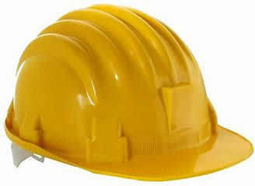Items in this category include hard hats, helmets, and bump caps. Different hats

or helmets are used for other applications. Bump caps are designed only for

“walking tours” such as in a warehouse. They should not be worn in place of a

hard hat in a construction site.

## **High visibility clothing**

Image courtesy granger.com

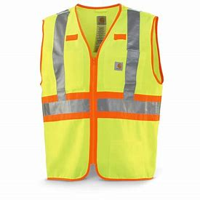Remember, clothing must meet ANSI/ISEA 107-210 *High Visibility Safety Apparel and Headwear* standards and specifications.

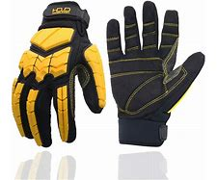

## **Hand protection (gloves)**

Types of gloves may be utility gloves, chemical resistant gloves, anti-vibration gloves, thermal gloves, and welding gloves.

Select and use the type of glove appropriate to the task.

Image courtesy granger.com

## **Hearing protection**

Image courtesy granger.com

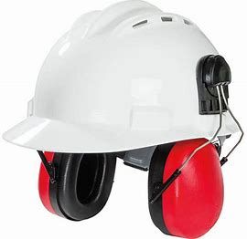This category includes earplugs, electronic earplugs, earmuffs, and hardhats with earmuffs. Ear protection should be worn at any time that sound levels reach a dB rating of 85 or more.

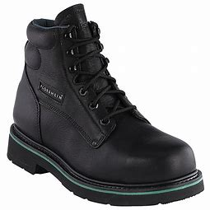

## **Footwear**

This category includes all safety footwear (steel and

composite toe) boots. All boots should have a steel or

Image courtesy granger.com

composite toe that meets ANSI and ASTM specifications too

meet the needs of the job you will be doing.

Image courtesy granger.com

## **Eye and face protection**

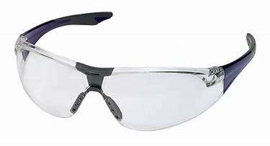This category includes safety glasses, over-eyeglass goggles, and face shields (aka visors). Always use the appropriate eye protection for the job. At a minimum, safety glasses should also be considered part of your daily attire.

Image courtesy granger.com

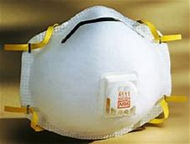

Image courtesy granger.com

## **Breathing apparatus**

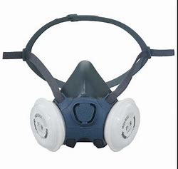This category includes simple dust masks, particulate

masks, full-face respirators, and breathing respirators. The

type of breathing protection should be used that is appropriate

to the job. For example: if doing mowing, dust or particulate

masks will work just fine. If working in environments that have caustic vapors,

then a full-face respirator should be used to protect the eyes and lungs.

## **Fall management equipment**

Image courtesy granger.com

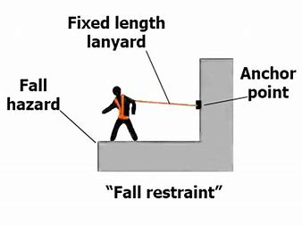Items in this category include safety fall restraint and fall arrester

(aka as fall limiter) harnesses. All fall restraint and fall arresters

have an “expiration date” on them. Fall restraints are designed too

keep you from falling – such as limiting the distance you can go

from a terminal point. Fall arrest systems are designed to protect

you after you fall and restrict the fall to prevent you from colliding

with the ground or structures.